Electrostatic field
Calculating 
1. Superposition
(1) point charge 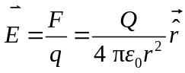
(2) discrete point charges 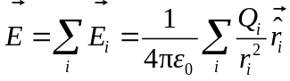
(3) continuous charge distribution 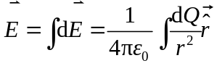
steps ：
(1) set up coordinate system (original point, positive direction)
(2) calculate 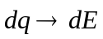 （magnitude，direction）
(3)obtain 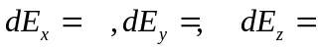
(from symmetry 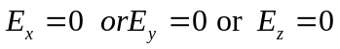）
(4) integrating 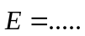or 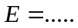(direction)
About density (sphere)
Examples：
(1) electric field a distance x from a infinite wire of uniformly distributed charge（λ,x）

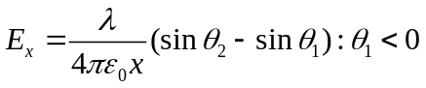 infinite：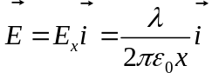
x
o
(2) A ring of charge （Q,R，x）

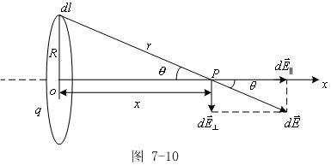

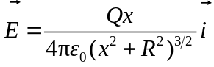

(3) infinite large uniformly charged plane（σ,R）
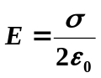

2. Applying Gauss’s Law
Gauss’s Law
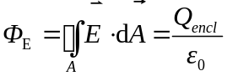
The net electric flux through any closed surface is equal to the net charge Q_{encl} enclosed by the surface divided byε₀
Steps ：
(1) Analyze the symmetry of the charge distribution
(2) Choose the Gaussian surface
(3) Find out the equation according to Guass’s law（calculate Qenc）
(4) Solve for （Magnitude and direction）
Examples：
(1) infinite large charged plane （σ,）

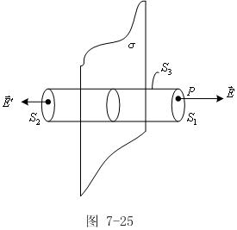

（2）

(2) A thin spherical shell (Radius R, net charge Q>0 uniformly)（Q，R）
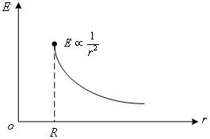
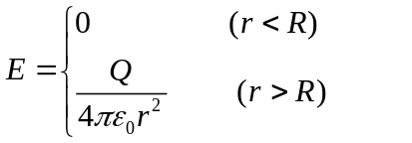
Direction: radially outward

(3) A Solid sphere (Radius R, net charge Q>0 uniformly)
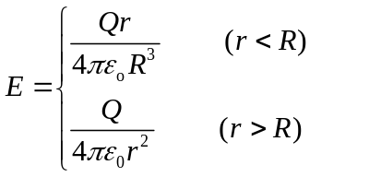
Direction: radially outward
(4) Long uniform line of charge (λ>0)
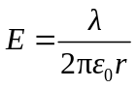
(5) Long solid cylinder with a linear charge density λ and radius R（R，λ）
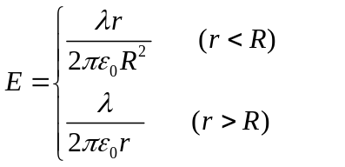
3. Relation between V and E
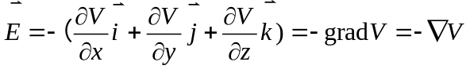
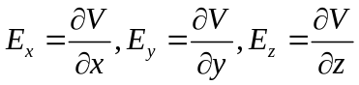

The electric field lines point in the direction of decreasing electric potential

Calculating V
1. 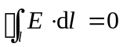
The line integral of the electrostatic field around a closed loop is zero.
Electrostatic force is a conservative force and electrostatic field is a conservative fiel(4)
2. electric potential
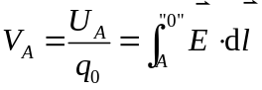（point charge）
Electric potential energy: 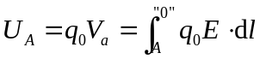
Work done by electric force:
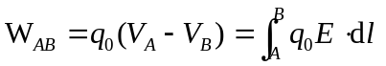
The work done by the electric force depends only on the initial and final positions and is independent of the path taken.
3. calculating V
(1) line integral of electric field ：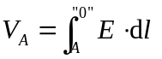
Electric potential difference: 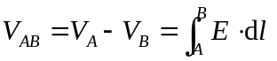
“0” is chosen to be zero potential energy

(2) superposition：
a point charge 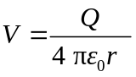
(2) discrete point charges 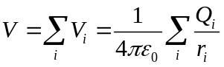
(3) continuous charge distribution 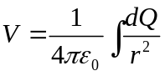
Examples：(1) Potential due to a ring of charge （Q,R，x）
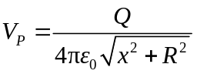
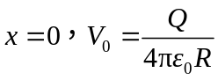
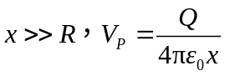

(2) Potential due to a thin spherical shell of Radius R carrying a uniform distributed charge Q
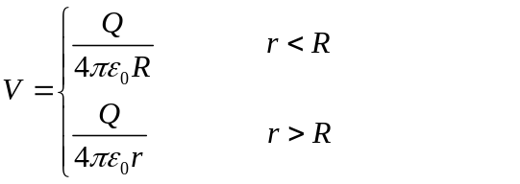

(3) Potential due to a A Solid sphere of Radius R carrying a uniform distributed charge Q .
